**Staff Aumentation**

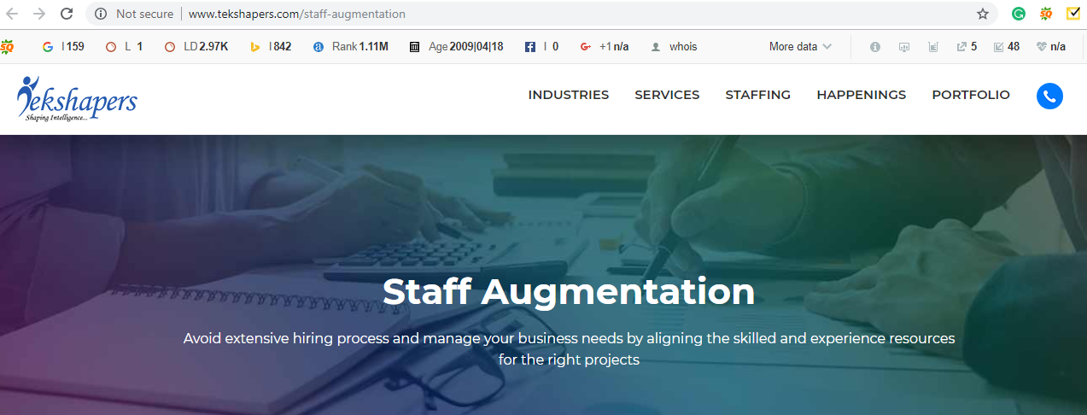

Text to be replaced

**Our service ensure that you focus on your core business while we do the rest**

**Next>>**

Our IT Staffing team specializes in providing on-site, high caliber, motivated IT professionals for temporary consulting, temp-to-hire or permanent employment for an individual as well as full team placements.

NUNC is specialized in bulk staffing needs in RPO (Recruitment Process Outsourcing) model adhering to the defined SLAs. Below are few staffing models, very common across most of our customers in USA and India locations. NUNC offers the most reliable and timely staffing services in the market trendy technologies. We have got a decent record of providing staffing services even for the niche technologies. The most accurate services as per the staffing needs is provided for our clients with best in class services.

**Our Approach**

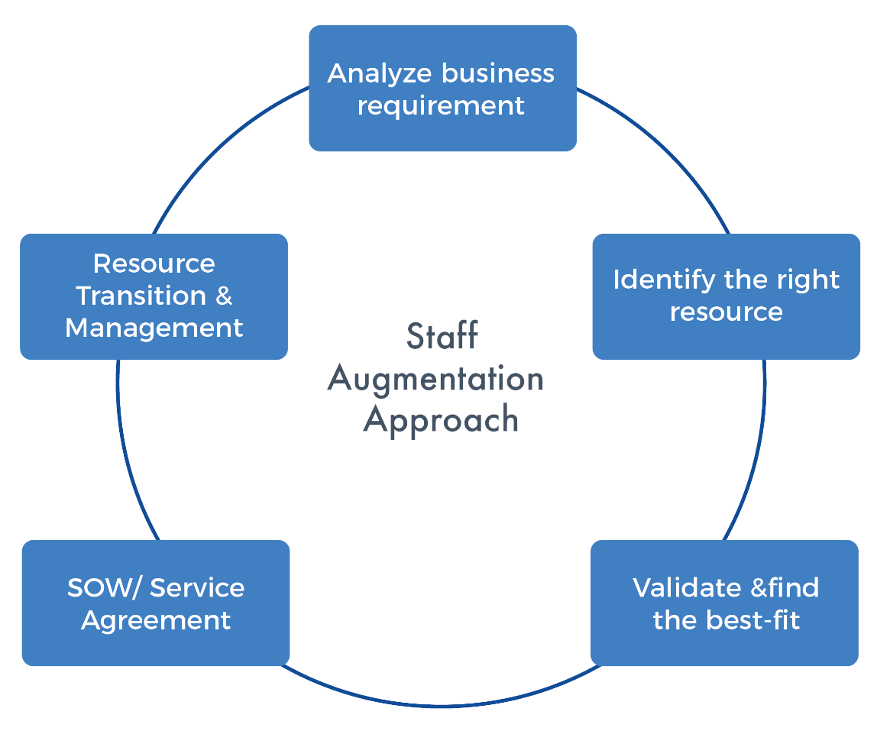

**Our Services:**

**Contracting:**  
NUNC supports your internal staff with short or long term resources specializing in the technology, business area, or role needed within your environment.

**Direct Hire:**  
With the intent of hiring an individual as your employee after a pre-determined period, NUNC will source, recruit and on-board the desired person with a transition period acceptable to any business.

**Contact-to-Hire:**  
NUNC supports the hiring needs of companies that prefer to hire individuals to be a part of their team from the beginning. NUNC will locate, select and help secure the best talent that will immediately become employees of our Clients.

**NUNC Provides 24x7 highly enhanced Staffing & Consulting Services**

* Adapt to the changing market conditions
* Innovate continuously
* Align IT with business goals
* Optimize costs, while maintaining high customer satisfaction
* Accelerate time-to-market for new products and services
* Meet industry standards and compliance requirements
* Leverage emerging technologies effectively

Next>>

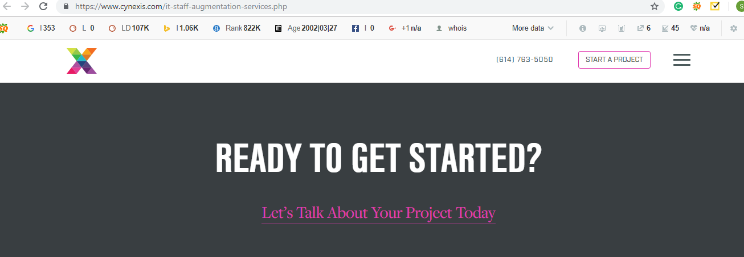

**Text to be replaced**

***Please contact us to learn more about our Staff Augmentation Services.***

***Image suggestion***

[**https://www.shutterstock.com/image-photo/recrutiment-hr-concept-businessaman-pressing-on-481500031?src=X3C_nIXU6syEZBtDECEw4g-1-8**](https://www.shutterstock.com/image-photo/recrutiment-hr-concept-businessaman-pressing-on-481500031?src=X3C_nIXU6syEZBtDECEw4g-1-8)

[**https://www.shutterstock.com/image-photo/business-man-holding-group-worker-icons-574917619?src=-r3DYQHjE9L7Ybp0u5wurw-1-43**](https://www.shutterstock.com/image-photo/business-man-holding-group-worker-icons-574917619?src=-r3DYQHjE9L7Ybp0u5wurw-1-43)